Dis-Indo-Java-Mastodon sculpture of shaman

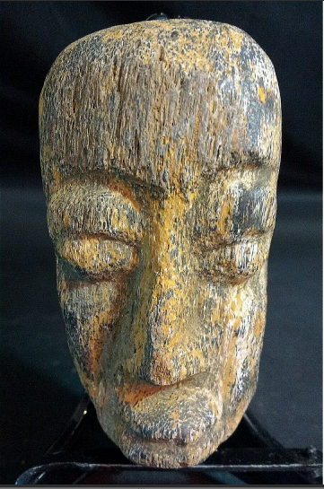 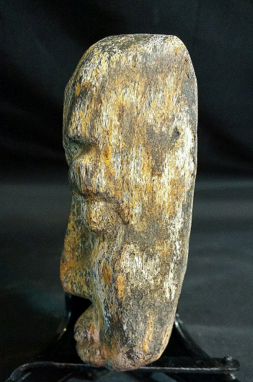 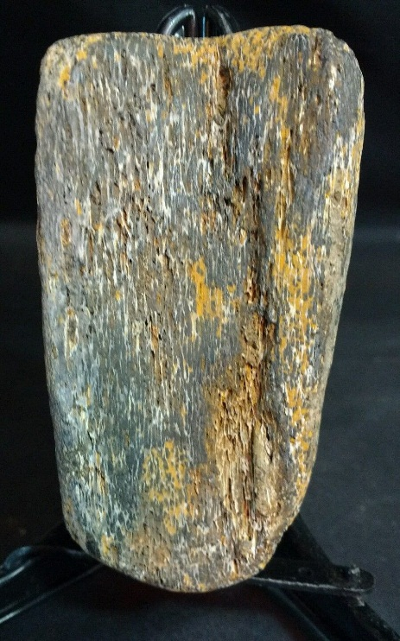

**Accession Number:**

**LC Classification:**

**Date or Time Horizon:** ca 60,000 BP when Sunda was a tundra

**Geographical Area:** Bengawan Solo River, Ngandong, Java, Indonesia

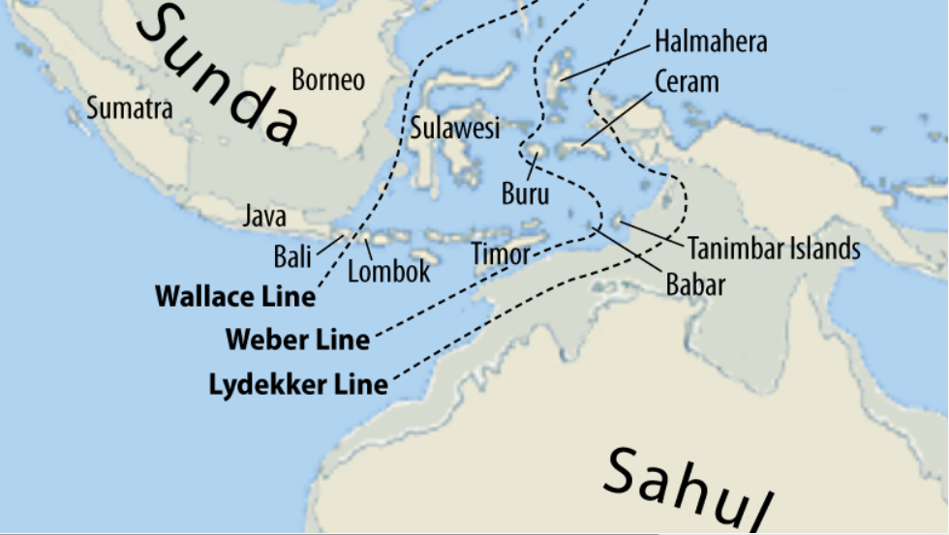

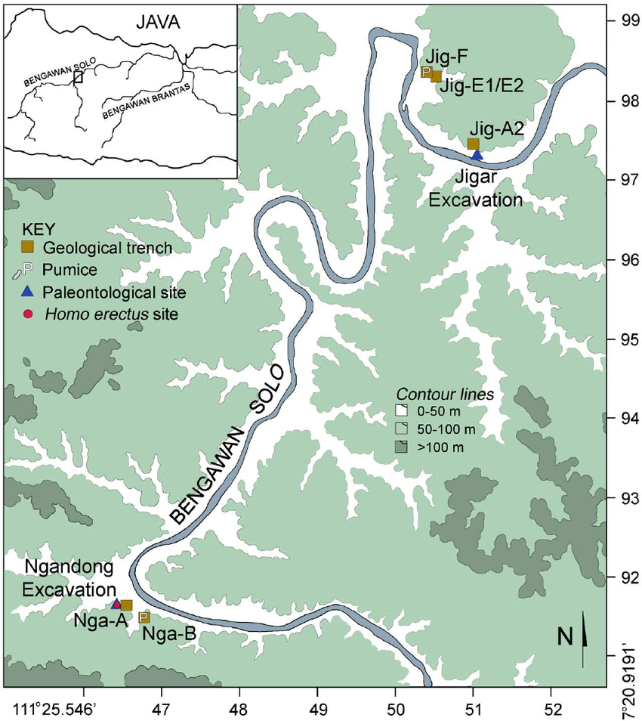

Map of Java showing location of study area (boxed) adjacent to Solo River and a contour map of Ngandong and Jigar localities (base map and latitude/longitude coordinates after J.P. U.S. Army Map Service topographic square 63-046).

**Cultural Affiliation:** in the Ngandong region a series of geographically and relatively isolated lineages of hominins lived during the middle Pleistocene. The age of the deposits at Ngandong and Jigar with a maxima of 546 ka based on the argon results and a minima of 143 ka based on the oldest of our fully modeled combined ESR/U-series ages.

**Medium:** Mastodon bone

**Dimensions:** H 3.58 in, W 2 in, T 1 in.

**Weight: 158 gm**

**Provenance:** Sunda

**Condition: Museum quality**

**Discussion:**

Sunda Land was a land-bridge linking the Southeast Asian mainland with the islands of Sumatra, Java and Kalimantan, providing a migration passage for *Homo erectus* and vertebrate fauna, such as mastodons. Based on archaeological evidence, in the Pleistocene, hominins and vertebrates clustered near non-marine environments such as lakes and rivers. Evidence of skeletal remains of *Homo erectus (paleojavanicus)* in Java in the Early Pleistocene (1.6–1.0 Ma) and *Homo erectus ngandongensis/soloensis*. during the Mid to Late Pleistocene (1.0–0.125 Ma) confirms the time horizon of these hominin migrations.

The Sangiran Dome in Java was created millions of years ago through tectonic uplifts, and the dome was then eroded exposing beds within the dome which are rich in archaeological remains. It has yielded more than 152 fossils of *Homo erectus* from the Early to the Mid Pleistocene based on evidence from the sediments of the Bapang Formation. This number of *Homo erectus* fossils represents more than 77% of the total hominin specimens found in Java of the earliest human occupation when Sunda Land first emerged from the Java Sea.

Therefore, in this period from 1.6 Ma to 1.0 Ma, the Sangiran Dome and other uplifts like the Ngandong on the Bengawan Solo River, near where this mastodon fossil was discovered, was the home for migrating hominins from Southeast Asia and their industries of which this mastodon fossil, worked into a human image, is an example.

**References:**

Sold by [**flower2992**](http://myworld.ebay.com/flower2992) ( [459](http://feedback.ebay.com/ws/eBayISAPI.dll?ViewFeedback&userid=flower2992) )

**ebay fast n free icon  FAST 'N FREE**

Estimated delivery **Friday, Feb 3, 2017**

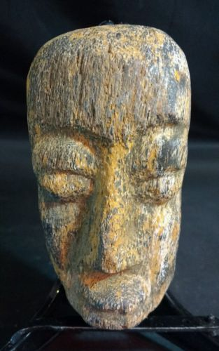

[**Mastodon/Stegodon Carving - Island of Java. Fossil bone carving #2**](http://www.ebay.com/itm/262820668987)

|  |  |
| --- | --- |
| Item price | $179.00 |
| Quantity | 1 |
| Item number | 262820668987 |
| Shipping service | USPS Priority Mail Small Flat Rate Box |

**Shipping address**

**Ralph J Coffman Jr**

149 Atlantic Ave

Swampscott MA 01907-2427

United States

**Order total**

|  |  |
| --- | --- |
| Subtotal | $179.00 |
| Shipping | Free |

**Total**

$179.00